|  |
| --- |
|  |
| Assignment 2 |
| AR Jewellery Design and Implementation  (Group Assignment) |
| Submission Date: 8th December 2019 |
| **Prepared By:** |
| **Vimita Vaidya (1000063758)**  **Wisanu Boonrat (1000069539)**  **IX 713001 Computer Human Interaction Design** |
|  |

# Table of Contents

Table of Contents 2

List of Figures 2

Executive Summary 3

Introduction 3

Application Screen Flow 4

JakobNielsen’s 10 Usability heuristics principal 5

1. Visibility of system status 5

2. Match between system and the real world 6

3. User control and freedom 6

4. Consistency and standards 7

5. Error prevention 8

6. Recognition rather than recall 9

7. Flexibility and efficiency of use 10

8. Aesthetic and minimalist design 10

9. Help users recognise, diagnose, and recover from errors 11

10. Help and documentation 11

Implementation 12

Evaluation 13

Future Work 14

References 15

# List of Figures

Figure 1 AR Jewellery Screen Flow 4

Figure 2 Landing page and Warning page 5

Figure 3 Try Item guideline Page 6

Figure 4 Product details page 7

Figure 5 Warning message 8

Figure 6 The highlighted item in the camera screen. 9

Figure 7 Reference image for a watch to detect 3D model 10

Figure 8 Warning message about the supported devices 11

Figure 9 User guide while trying the item 11

Figure 10 A list of products in a mobile app screen vs in a camera screen 13

# Executive Summary

This report describes the AR Jewellery application which is an e-commerce android application using Augmented Reality technology that allows the user to try the product such as a watch, ring, bracelet, and necklace.

The screen flow of the application is provided for the best understanding of the application. The design of the application is developed, reviewed and revised based on various concepts of UX design. The specific details of the design are discussed in Jakob Nielsen’s 10 Usability heuristics principal which can answer the question that why and how the application should be introduced to the user. The implementation section describes the related technologies and obstacles that the developers met in the development phase. The evaluation section refers to the 10 usability heuristics section and also includes the reason why the application needs to be an android application instead of the pure AR application in another platform. Lastly, the future work section indicates how the application can be improved by adding more features.

# Introduction

The goal of the project is to create an AR Jewellery Android App for object visualisation such as s watch, ring, bracelet and necklace that gives our potential customers the new unique user experience and allows them to look at the item more precisely and in more detail.

Using augmented reality allows us to bring virtual objects in the real world. In this way, an augmented reality app for smartphone owners can turn all items of catalogs into 3D animated models. In jewellery or watch it’s all about presentation and showcases. People only need to point their mobile devices onto the showcases.

# Application Screen Flow

The AR Jewellery application provides the user with a landing page and then directs the user to the list of jewellery categories screen. When the user clicks at the category such as the watch, the user will be directed to the List of Products screen which shows all the watches with details and prices. After that, the user needs to choose a specific item, and then the Product Details screen will show up. In this screen, the user is allowed to click the TRY ON button which directs the user to the instruction screen to print the AR Reference Image that will be used in AR Camera screen. When the user has the printout of AR Reference Image, they are ready to try the item by using Augmented Reality.

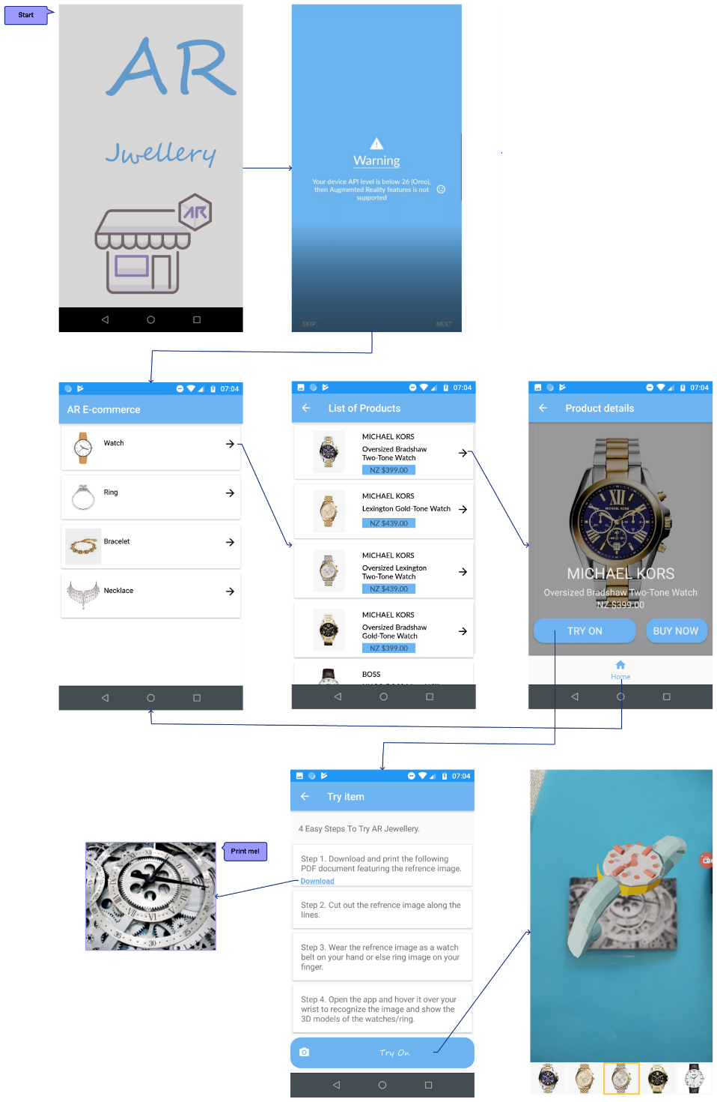

Figure 1 AR Jewellery Screen Flow

# JakobNielsen’s 10 Usability heuristics principal

The original conceptual modeling of AR Jewellery is considered in various aspects of how to design a good product by applying the Universal Design Principal, considering the Human Limitation and Human Cognitive Processes. When it comes to the implementation phase, the design has been reviewed and revised by applying the 10 Usability Heuristics Principal.

## Visibility of system status

The application will inform users about what is happening in a specified time, through appropriate feedback [2]. For example, showing progress bar while opening a website or in an application which shows what is happening to the user.

In order to apply system visibility in AR Jewellery application, a landing page will be provided that introduces user that this application is about e-commerce and warning page that includes message to user that, "if device API(Application Programming Interface) level is below 26 (OREO), then Augmented Reality features are not supported”.

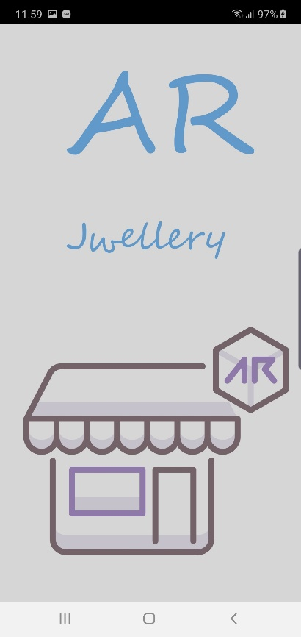 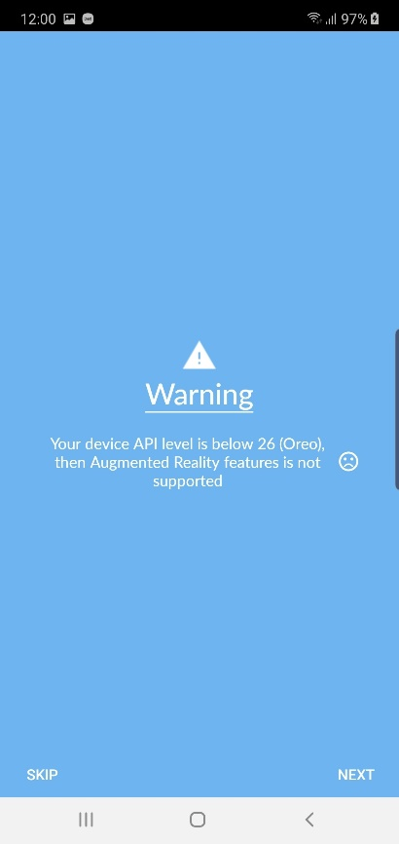

Figure 2 Landing page and Warning page

## Match between system and the real world

The program will speak the language of the user with user-friendly words, phrases, and definitions rather than program-based concepts [2]. In other words, it makes designs, label interactions and conversations more familiar to the real world. For example, the recycle bin icon is the same as the real bin, and the icon itself shows whether it has files in it or not.

Using user-friendly language in the AR Jewellery app, where users can easily understand what's going on, as well as the camera icon on the Try-On button where users can easily get the idea that after a click on this they can try item virtually on their self.

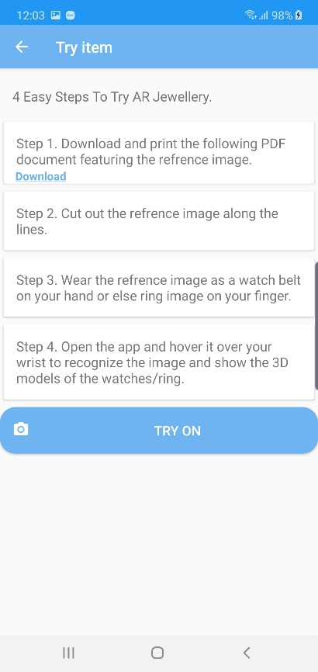

Page name which can introduce user that it is a Try Item Page.

Moreover, the Camera button icon redirects user for the next action.

Figure 3 Try Item guideline Page

## User control and freedom

This principal says that the application or website design should support undo or redo operation. Users frequently wrongly select System functions and will need a marked "emergency exit" to leave the undesirable state without a longer dialogue [2]. For instance, if you attached a large file in Gmail by mistakenly, you can cancel it before its fully uploaded.

Overall, if the user makes a simple mistake, you can always undo and recover from it. In this application will provide the back button at the top left corner of action bar which redirects the user to previous activity. Besides, it includes the home button which can redirect the user to the home page.

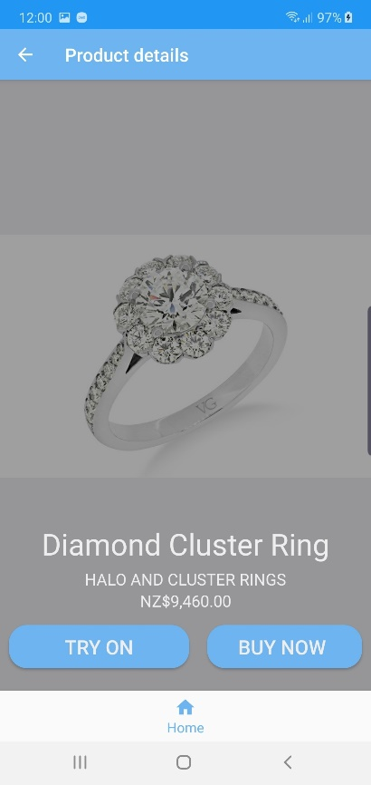

Home button which can redirect the user to home page

Back button which can redirect the user to the previous page

Figure 4 Product details page

## Consistency and standards

Users shouldn't have to worry if different words, scenarios or actions mean the same thing [2]. For example, we can always find sign-in, profile details and shopping cart information at the top right corner. Same as in Microsoft Word, Excel, and PowerPoint all use the same style toolbar with the same primary menu options: Home, Insert, Page Layout.

In this application, the user can easily interact with the activity. The app has a back button on the action bar top left corner on every page, same as in other applications.

## Error prevention

A careful design that avoids problems in the first place is even better than good error messages. It says that the developer can design and give the user an understandable message. For example, when you choose password tips are provided to prevent errors and password strength is calculated and displayed as you type.

For the AR Jewellery app, it includes the warning message at the beginning for the users which tells that the device API level must be more than 26.



Figure 5 Warning message

## Recognition rather than recall

Reduce the memory load of the user by displaying items and behaviors and choices [2]. The developer can remember during designing a project that their design should make things easy for the user through their user interface, message or dialogue or giving a history or recommended choices to them.

In AR Jewellery, the camera screen has provided a list of items from the selected jewellery category and highlight the one that the user is trying on. This can help the user to recognize the item they currently choose and compare it the other items on the list.

|  |  |
| --- | --- |
|  |  |

Figure 6 The highlighted item in the camera screen.

Another example, in any e-commerce application or a website such as amazon enables features for user recommendation of products where they can get ideas and choices of the product. In this AR Jewellery app, this principal will be fulfilled in future enhancement which enables user recommendation of products and recently viewed items. Therefore, the user can facilitate this feature.

## Flexibility and efficiency of use

While building a system, the developer can design a system in a way which gives more option to the user so that the user can access it fluently.

Here, in this system guide or steps will provide to the user’s how they can try the item on their self. Also, it has provided a reference image, where the user downloads and use it while trying the item.

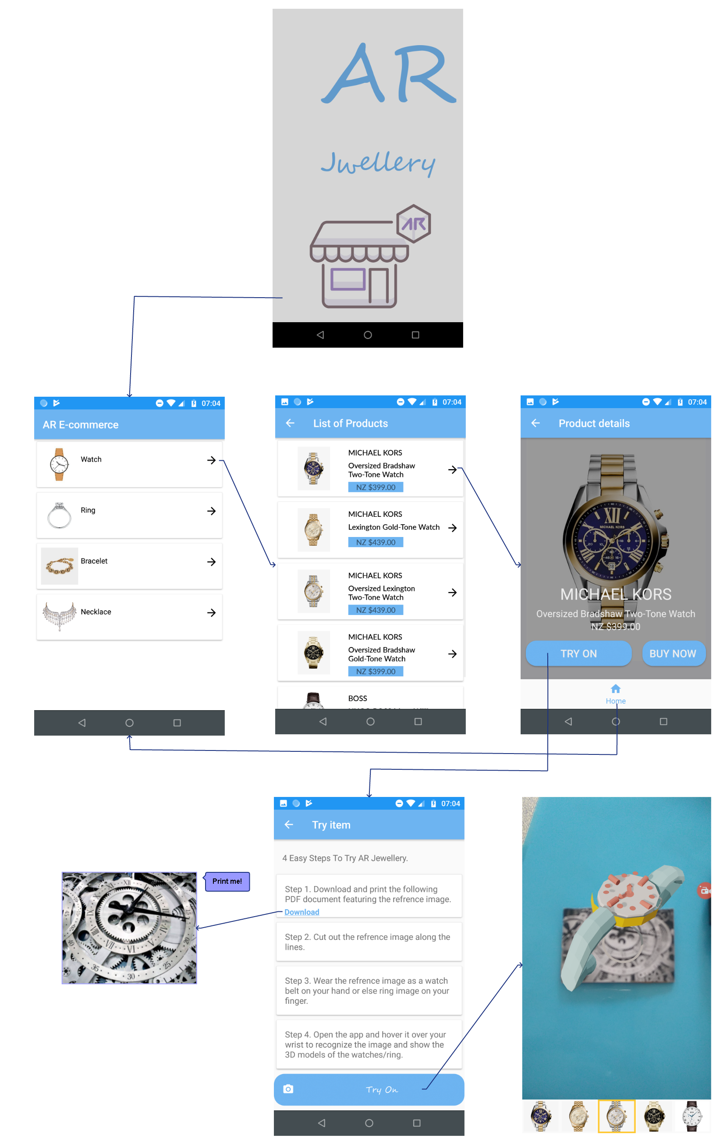

Figure 7 Reference image for a watch to detect 3D model

## Aesthetic and minimalist design

The developer can build a design prototype in a way that have relevant and minimal information. A good example of this is a Google search engine.

For the AR Jewellery app, the overall design is minimal with minimum and relevant information provided to the user. In the technical perspective, the application is built by using the color, shape, and typography theming in the Material Design provided for the android application.

## Help users recognise, diagnose, and recover from errors

In AR Jewellery app, the only one warning message at the beginning of the application which says the user can not be able to run AR feature with a lower API version.

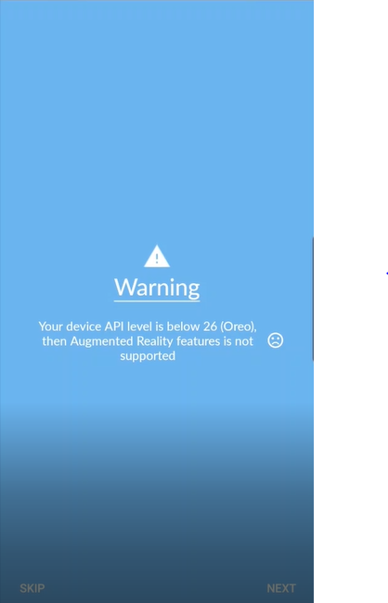

Figure 8 Warning message about the supported devices

## Help and documentation

Developers can provide help or quick guidance for the user on their system in their system design.



Figure 9 User guide while trying the item

# Implementation

The following programs are used to implement the AR Jewellery application. The 3D models are provided by Google Poly which is allowed the developer to use them under the Creative Commons licenses [6].

|  |  |  |
| --- | --- | --- |
| **Programs** | | **Descriptions** |
|  | Android Studio | Android Studio provides the fastest tools for building apps on every type of Android device. |
|  | AR Core (Sceneform) | To enable the Augmented reality feature in the android application. Sceneform makes it easy to make 3D scenes in AR and non-AR applications in practical [7]. |

Table 1 Development tools

The development tasks are divided into 2 subtasks. The first subtask is to develop an android application for displaying all the products, and the second subtask is to develop an AR camera for trying a specific product. There are some difficulties in the development process which are:

1. The android emulator does not work properly for testing the AR camera. The emulator works very slow when it renders the virtual scene.
2. The reference image for placing a 3D model cannot be detected when running the application in the emulator.
3. The real device has the supported android API version for testing AR Core, but there is a critical bug in AR Core which happens in the developer’s device. This bug is fixed in the higher android API version.
4. From the application testing, there are some concerns about the constraint of the reference image that it may need to be a flat image like a printout picture rather than a picture of real-world objects like a hand or the real ring.

# Evaluation

In the Jakob Nielsen’s 10 Usability heuristics principal section of this report, the application is discussed in detail that it is implemented to meet all the criteria of 10 Usability heuristics principal. Thus, this section will evaluate the overall design of the application.

Instead of starting the application from the AR Camera screen and allowing the user to manipulate the available features and options from that point, the developers decide to begin the application from a basic android application. The user needs to select all the options to find a specific product before trying it.

The advantage of introducing the application in this way is to educate the user to get familiar with the look and feel of the application which is similar to many applications in the market. And then instruct the user to learn how to use the Augmented Reality camera to try the product. In the final step, the user will be allowed to select the try-on product from the camera screen.

|  |  |
| --- | --- |
|  |  |

Figure 10 A list of products in a mobile app screen vs in a camera screen

# Future Work

To improve the AR Jewellery application in the future, there is a list of features to implement. For example:

1. Login – to record the user profile.
2. Recommendation – to suggest the products by learning user profiles and behaviors.
3. Online Shopping – to find the products from various websites.
4. Social Network – to build and expand the communities of users and products.
5. Chat Bot – to service the user interactively.

From the features above, the AR Jewellery application still has the potential to be enhanced in many modules. It can even be considered to be proposed as a mini project for IT students.

# References

1. Anonymous. (2017, September 27). Wrist watch. Retrieved from <https://poly.google.com/view/1O9w8eHIA3W>
2. Liyanage, E. (2019, November 20). 10 Usability heuristics explained. Retrieved from <https://medium.com/@erangatl/10-usability-heuristics-explained-caa5903faba2>.
3. Material Design. (n.d.). Retrieved from <https://material.io/develop/android>.
4. Poly by Google. (2017, October 11). Ring. Retrieved from <https://poly.google.com/view/1DI2MXrQ9by>
5. Poly by Google. (2017, October 23). Ring pop. Retrieved from <https://poly.google.com/view/7ykBPo4vUvO>.
6. Remixing and Creative Commons. (2019). Retrieved from <https://support.google.com/poly/answer/7418679?hl=en&ref_topic=7424093>.
7. Sceneform overview |  ARCore  |  Google Developers. (n.d.). Retrieved from <https://developers.google.com/ar/develop/java/sceneform>.